NM2023TMID10227

Naan mudhalvan project

Estimation of business expenses.

college: Arignar anna government arts college

for women, walajpet, Ranipet district-632 513

Department of mathematics



Topic: Estimation of business expense

submitted by

Team leader: Sharmila.M

Team members:

1. Sharmila.M
2. Sobana.A
3. Soniya.S
4. Suganya.M

Introduction:

Overview

In the dynamic realm of entrepreneurship, one of the cornerstone practices for achieving financial stability and success is the meticulous estimation of business expenses.

Objective:

The objective of analyzing estimation of business expenses are as follow:

1. Compile a comprehensive List: Start by creating a comprehensive list of all possible expenses your business may incur.
2. Review Historical Data: Analyze past financial records to gain insight into your previous expenses. This data can serve as a valuable reference point for future estimates.
3. Market Research: Conduct industry research and competitor analysis to
4. understand typical expenses pattern.
5. Adjust for Growth: As your business grows, your expenses may change. Consider how different factors, such as increased production or expanded marketing efforts, might impact your costs.
6. Create Detailed Projections: Develop financial projections for the upcoming months or years, specifying your expecting expenses.
7. Incorporate a Contingency: It’s wise to include a buffer for unexpected or variable expenses that may arise.

Problem definition and design thinking:

Empathy map:

Empathy maps helps identify patterns and themes that are important to your projects, enabling you to understand the real problem to be solved.

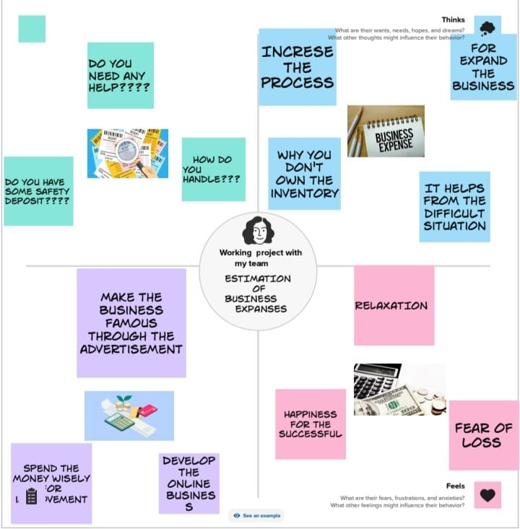

Ideation and brainstorming map:

An ideation mind map is a visual diagram that helps you organize and structure your thoughts and ideas. It works by creating a central idea or concept, and then branching out into smaller, related ideas that connect to the central idea.

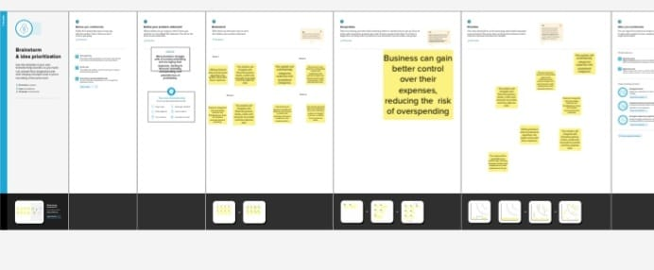Worksheet:

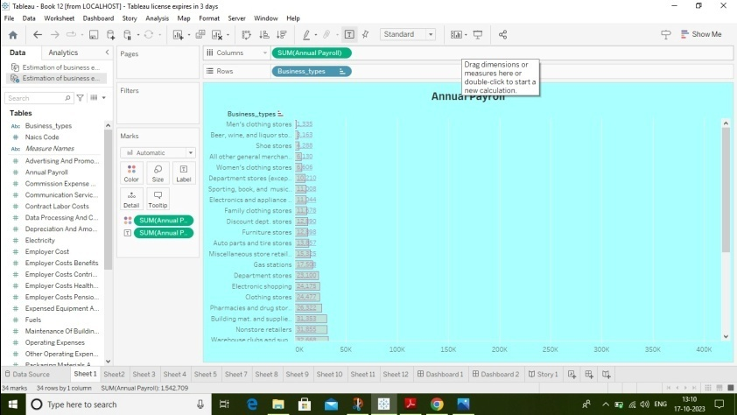

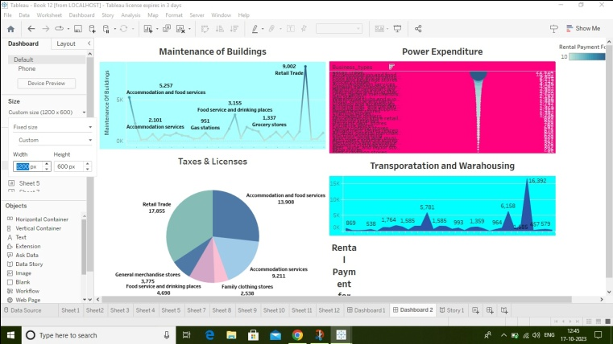

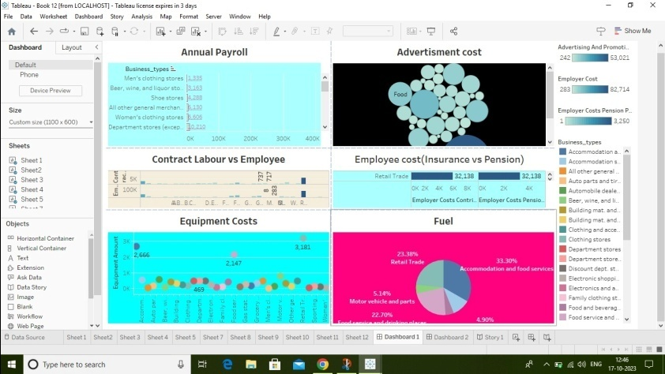

story:

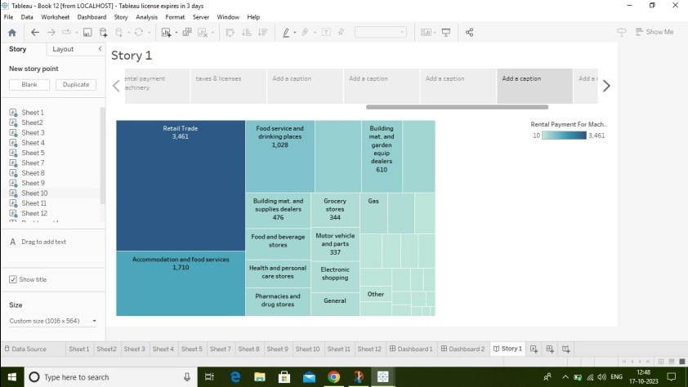

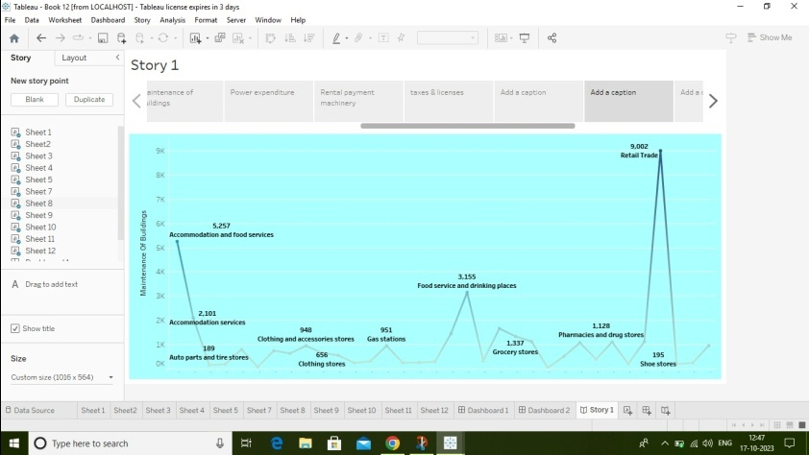

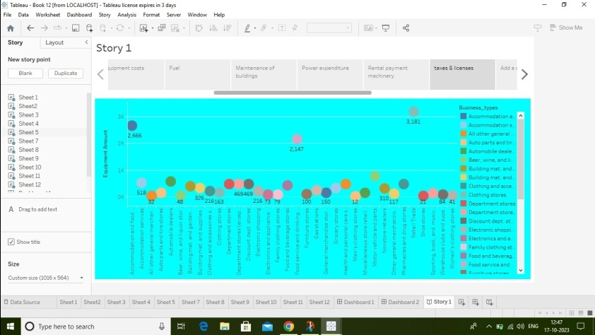

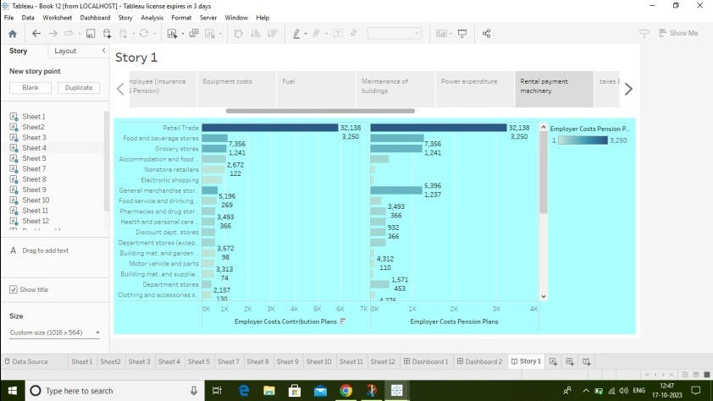

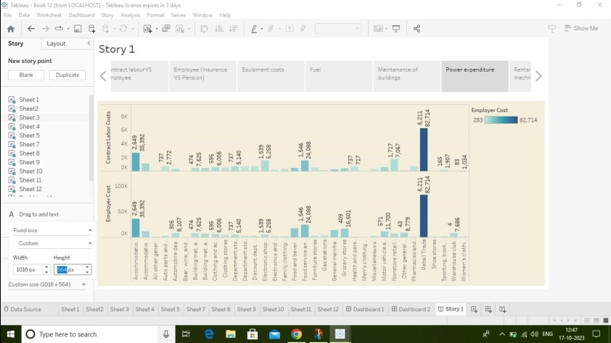

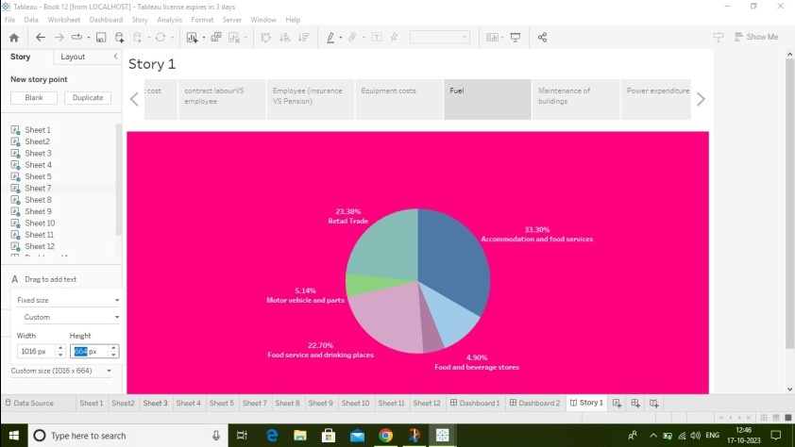

Conclusion:

Analyze your income statement, balance sheets, and previous expense reports to identify historical spending patterns.

Group expenses into categories such as payroll, rent, utilize, marketing, supplies, and more.